BUAN/OPRE 6398.003 Prescriptive Analytics

Homework 4

Team 6

Taeho Kim
Lin Li
Madhuri Kashyap
Manasa Venkatesh
Thomas Trieu
Yu-Min Wang

2.
1) 0, because the constraint 28 is binding (slack=0)
2) 4.5, because the slack =4.5
3) Not accepted. The shadow price=7 (for 12 is within allowable increase 50). Each extra labor hour will increase company’s profit by $7 which is less than the hourly rate $10.
4) Because shadow price is 40, 5*40 =$200. The total profit will decrease by $200.
5) No. 300*35%=105 > allowable decrease 100. So the current production plan will not be optimal.
6) 500-350=150 < allowable increase 175, so the current plan is still optimal.
The total profit will be = 3.5*$300 + 2*$500 = $1050 + $1000 = $2050

3.
1) Let t = -x, z=u-v
Minimize Z = -7t + 9y -6u + 6v
Subject to :
8t + y + 25u -25v ≥ 17
-2t -11u + 11v = 25
14y + u - v ≤ 191
-3t + 10y ≥ 48
t, y, u, v ≥0
2)
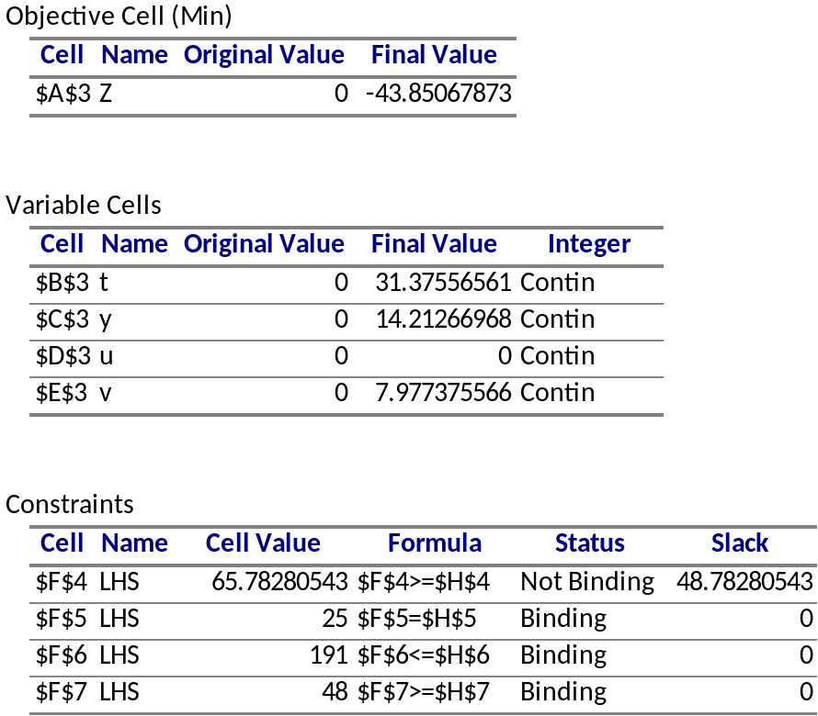

The optimal solution (t*,y*,u*,v*)= (31.37556561, 14.21266968, 0, 7.977375566),
Optimal objective function value Z* = -43.85067873

3) x*= -t* = -31.37556561, z* = u* - v* = -7.977375566
The optimal solution (x*, y*, z*) = (-31.37556561, 14.21266968, -7.977375566)
Optimal objective function value Z* = -43.85067873

4) Maximize Z = 17a + 25b + 191c + 48d
Subject to: -8a + 2b +3d ≥ 7
a +14c+10d ≤ 9
25a - 11b + c = -6

a, d ≥ 0,
b UIS,
c ≤ 0

4.
1) Answer report

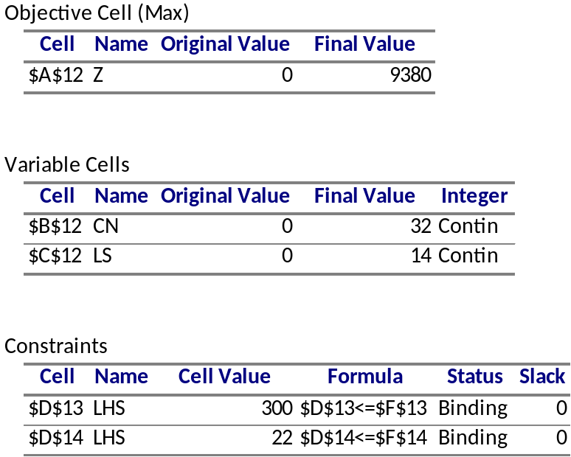

Sensitivity report :
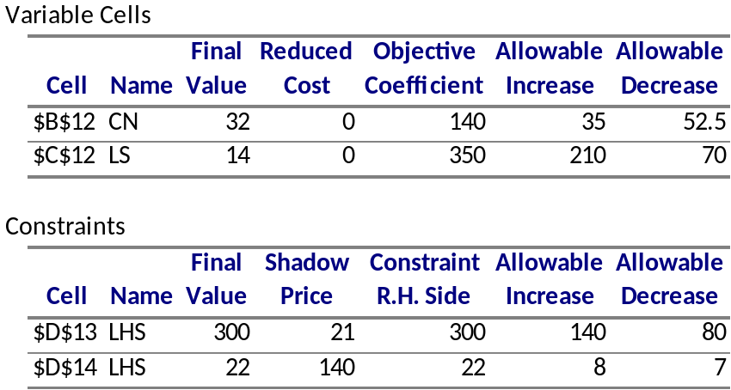

2) Minimize Z = 300a + 22b
Subject to: 5a+0.25b ≥ 140
10a + b ≥ 350
a, b ≥ 0

3) Answer report:
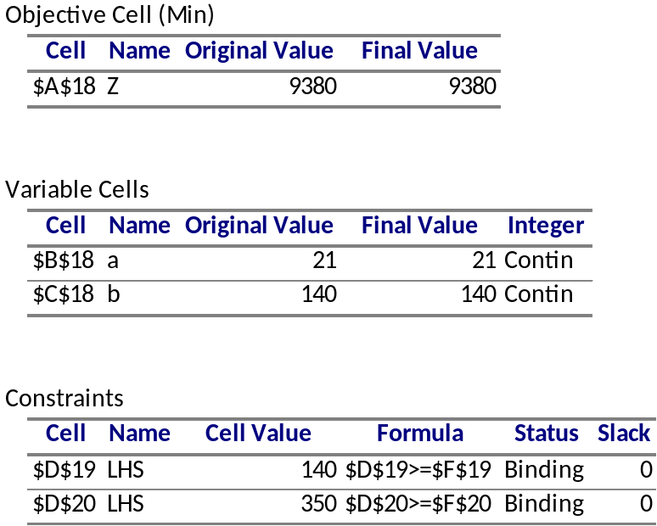

Sensitivity report:
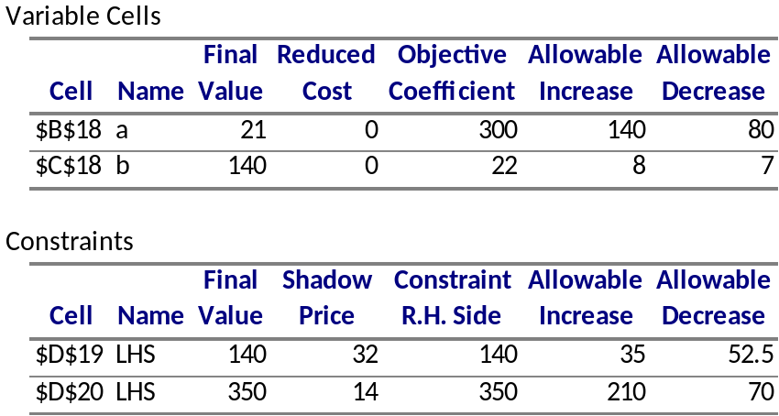

4)
a) YES. In primal LP the optimal objective function value Z*=9380, while in dual LP Z*=9380
b) YES. The optimal solution in primal = (32, 14), the shadow price in the dual = (32,14)
c) YES. The shadow price in primal = (21, 140), the optimal solution in the dual = (21,140)

5)
Maximize Z= 140x + 350y
Subject to: 5x +10y ≤ 300
0.25x + y ≤ 22
x, y ≥ 0

6) YES. The dual of dual is equal to the primal.

